Chemical Equilibrium

Select the alternative that correctly answers the following questions.

The next three questions refer to the energy profile diagram below for the generalized reaction:
A + B  C + D

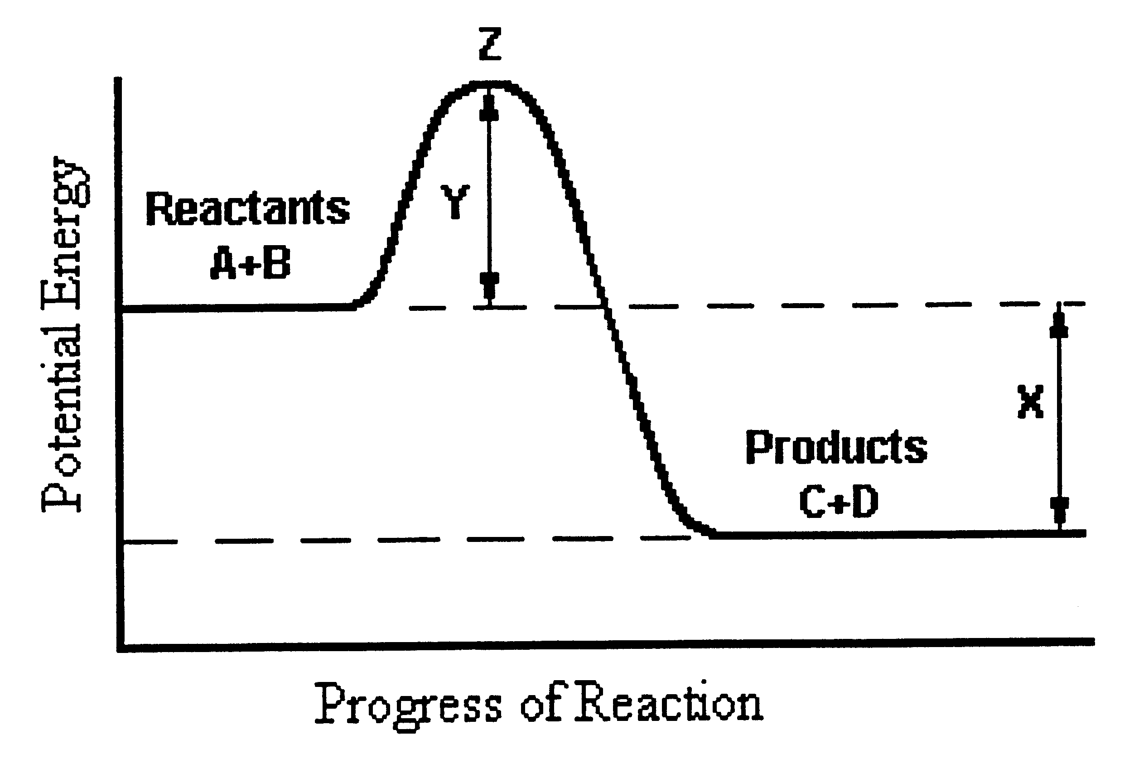

1. Which one of the statements below is incorrect?
a) The reverse reaction is endothermic with ΔH = X.
b) Z is the activated complex.
c) The activation energy for the forward reaction is equal to Y.
d) The activation energy for the reverse reaction is equal to X + Y.
e) At Z, the reacting molecules in the transition state are most likely to form products C and D.

2. The equilibrium expression, k, for the reaction: N₂O₄(g) 2NO₂(g), would be

a) k = [N₂O₄]
2[NO₂]
b) k = 2[NO₂]
[N₂O₄]
c) k = [N₂O₄]
[NO₂]²
d) k = [NO₂]²
[N₂O₄]
3. What would happen to the value of k in the reaction described in question 14, if the pressure of the N₂O₄ is doubled?

a) k would not be affected.
b) k would be halved.
c) k would be doubled.
d) k would increase by a factor of 4.

4. One way of producing ammonia is by the Haber process. In this process, hydrogen and nitrogen gases are reacted together and the overall equation is:

N₂(g) + 3H₂(g) 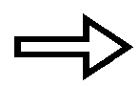 2NH₃(g) ΔH = -46 kJ moL⁻¹ NH₃ produced.

Using your knowledge of equilibrium and Le Chaterlier’s Principle, what conditions of temperature and pressure favor the production of ammonia?

a) High temperature and low pressure.
b) Low temperature and high pressure.
c) Low temperature and low pressure.
d) High temperature and high pressure.

5. The equilibrium constant, k, for the reaction, 2H₂(g) + O₂(g) ☑ 2H₂O(g) , is equal to 2 x 10⁸¹ at 25ºC.
This value suggests that

a) this reaction favors the forward reaction slightly more than the reverse reaction.
b) this reaction favors the reverse reaction slightly more than the forward reaction.
c) this reaction virtually goes to completion with little reversal.
d) this reaction virtually does not proceed forward and largely favors the reactants.

The next two questions refer to the equation below which shows bromine dissolving in water. Assume that the reaction is at equilibrium.

Br₂(aq) + H₂O(l) H⁺(aq) + Br⁻(aq) + HBr(aq)
red colorless

6. What observation would you expect if dilute acid such as hydrochloric acid were added to the system at equilibrium?

a) No observable change.
b) The solution would become colorless.
c) The solution would become red.
d) The solution would become green.

7. Which one of the following would NOT cause the reaction to shift to the right?

a) Addition of Br⁻ ions to the system.
b) Decreasing the [H⁺].
c) Addition of Br₂.
d) Addition of H₂O.

8. The equation below shows carbon and hydrogen reacting to form methane.

C(s) + 2H₂(g) CH₄(g) + 75 kJ

If the reaction has reached equilibrium, how could you increase the yield of methane?

a) Decrease the temperature.
b) Decrease the pressure.
c) Add a suitable catalyst.
d) Both (a) and (c) above.

The next two questions refer to the following information.

When dilute hydrochloric acid is added to a solution of potassium chromate, a solution of potassium dichromate is produced. This is an example of a reversible reaction where there are no visible changes to the colour of the solution formed once equilibrium has been reached.

2CrO₄²⁻(aq) + 2H⁺(aq) Cr₂O₇²⁻(aq) + H₂O(l) + 42 kJ

9. Which one of the following would NOT favor the forward reaction?

a) Addition of more potassium chromate.
b) Increasing the concentration of hydrochloric acid.
c) Decreasing the temperature of the solution.
d) Addition of water.

10. What would you expect to happen to the color of this solution if dilute sodium hydroxide is added?

a) The solution would become more intensely orange due to the forward reaction being favored.
b) The solution would become yellow due to the reverse reaction being favored.
c) The solution would remain orange due to the fact that sodium hydroxide is not one of the reacting species in this reaction.
d) The solution would become colorless due to the forward reaction producing more water molecules.

11. When hydrogen sulfide is passed into a solution of iron(II) sulfate, a black precipitate of iron(II) sulfide is obtained.

FeSO₄(aq) + H₂S(g) FeS(s) + H₂SO₄(aq)
OR
Fe²⁺(aq) + H₂S(g) FeS(s) + 2H⁺(aq)

Which one of the following would NOT change the concentration of Fe²⁺ ions at equilibrium?

a) Increasing the pressure of the hydrogen sulfide gas.
b) Adding more iron sulfide.
c) Adding more sulfuric acid.
d) Adding more sodium hydroxide solution.

12. Sulfur trioxide can be produced by the following reaction between sulfur dioxide and oxygen.

2SO₂(g) + O₂(g) 2SO₃(g) ΔH = -189 kJ moL⁻¹

If this system is at equilibrium, which of the following statements is TRUE?

a) Increasing the temperature could increase the amount of sulfur trioxide produced.
b) Decreasing the partial pressures of all gases present could increase the amount of sulfur trioxide produced.
c) Adding a catalyst could increase the amount of sulfur trioxide produced.
d) Adding more sulfur dioxide gas to the reaction chamber could increase the amount of sulfur trioxide produced.
13. Nitrogen dioxide is a dark brown gas, which can decompose to form dinitrogen tetraoxide. The mixture of these two gases will eventually reach equilibrium.

2NO₂(g) N₂O₄(g)

Which of the following statements is not true?

a) At equilibrium, both of these reactions have ceased.
b) At equilibrium the color of the gas mixture would remain constant.
c) At equilibrium, the rate of decomposition of NO₂ to N₂O₄ equals its rate of formation.
d) At equilibrium, the quantities of NO₂ and N₂O remain the same.

